TASK#01:

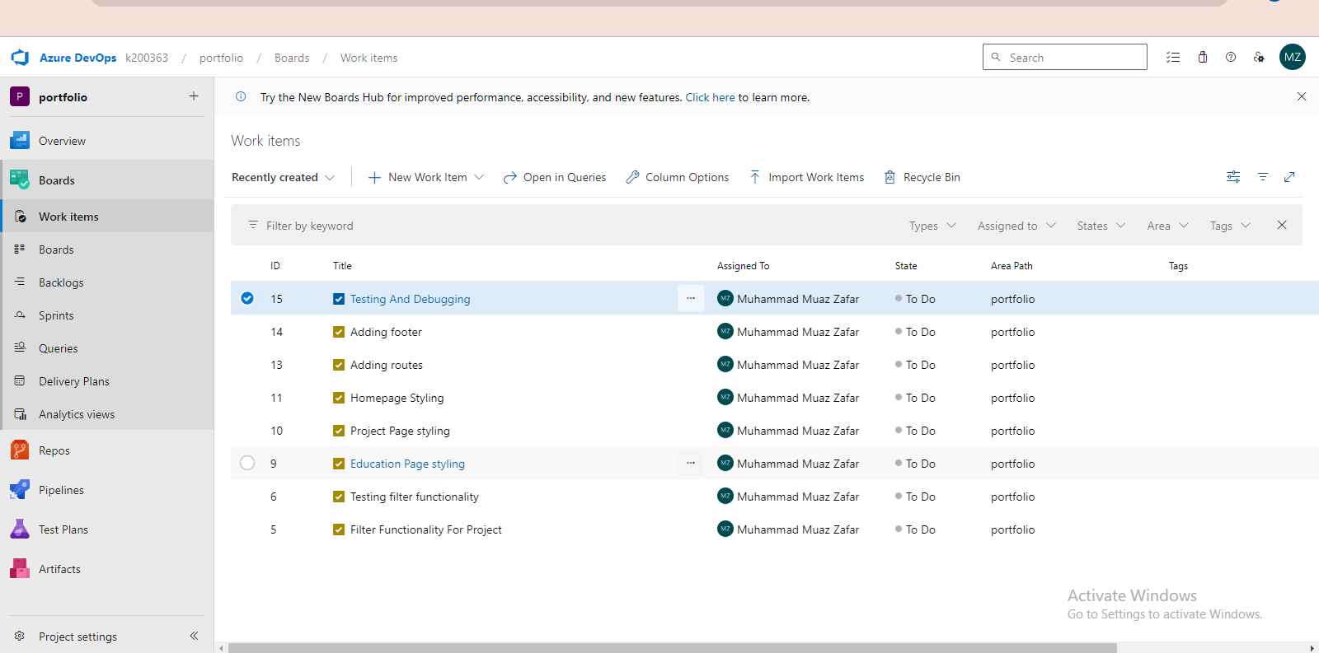  
Tasks are assigned and created.

TASK#02: